Appendix 1: Assignment submission cover sheet
ASSIGNMENT SUBMISSION COVER SHEET

Cse24-103
Student Id:

Ryan shabba mosenyegi
Student names:
Cse24-103@thuto.bac.ac.bw
Student email:

2025
Cohort:

CSE202 – INTRODUCTION TO OBJECT ORIENTED ANALYSIS WITH JAVA
Assignment title:

19 September 2025
Computer Systems Engineering
Date of submission:

Programme of Study:

Year 2
Year of Study:

Intellectual property statement
By checking the box below, I certify that this assignment is my own work and is free from plagiarism. I understand that the assignment may be checked for plagiarism by electronic or other means and may be transferred and stored in a database for the purposes of data-matching to help detect plagiarism. The assignment has not previously been submitted for assessment in any other unit or to any other institution.I have read and understood the Botswana Accountancy College plagiarism guidelines policy.
☐ Agree Signature…………………………………….

OOAD JAVA ASSIGNMENT 2025

PART A: REQUIREMENTS ELICITATION AND BEHAVIOURAL MODELING
- Requirement elicitation
Interview for functional and non-functional requirements

Interview Record: Banking System Requirements Elicitation

Date: 17/09/2025
Interviewer: Themba Moeng (Lecturer)
Attendees: Ryan mosenyegi, Other Students

Functional Requirements Extracted from Interview

Themba Moeng :

· The banking system has "two main components" addressing features for "banked client" (customers) and "employee within the bank itself" (bank staff)
· Features and services expected by banking clients
· Features and services expected by bank employees

Non-Functional Requirements Extracted from Interview

Time 1:48-2:29 - Themba Moeng:

· Security requirements: "How the system would be secured"
· Performance requirements: "Speed or response time" with "certain maximum response time when the user is interacting with the system"

Time 2:29-3:05 - Themba Moeng:

· Non-functional requirements "apply to all types of users" and are "stated from the system point of view"
· Unlike functional requirements which are "specific to this type of person" (user-specific)
· "If you are doing security, it's security for all. If it's response time, it's response time for all"

Key Clarifications for Banking System

Themba Moeng:
The banking system requires understanding of different user perspectives:

· Banking clients - External customers using banking services
· Bank employees - Internal staff managing banking operations

Summary of Requirements for Banking System

1.1 Functional Requirements (User-Specific Services)

- User Registration System – Allow new customers to create banking profiles
- Account Management – Open, view, and manage different account types (Savings, Investment, Cheque)
- Transaction Processing – Deposit, withdrawal, and transfer capabilities
- Account Information Access – View account details and balances
- Transaction History – Access to past transaction records

1.2 Non-Functional Requirements (System-Wide Qualities):

· Security measures (encryption, access control)
· Performance standards (response time, reliability)
· Quality attributes (consistency, availability)
· Compliance requirements (auditing, regulations)

The interview emphasized that functional requirements must be articulated from the user's perspective and are specific to different user roles (customers vs. employees), while non-functional requirements describe system-wide quality attributes that apply universally regardless of user type.

- Structural UML modelling
2.1 System Use case Diagram
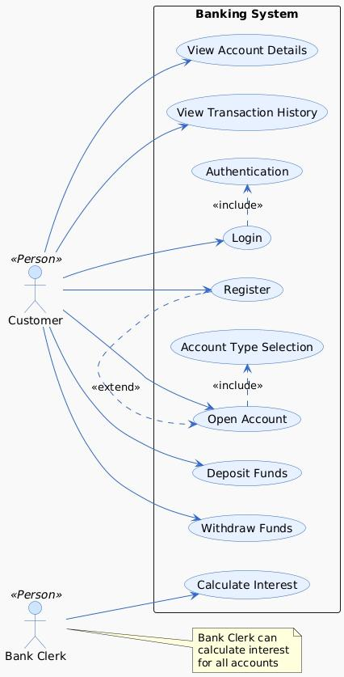

This banking system allows users to do banking operations. The two main actors are the Customer and the Bank Clerk.
For Customers:
· They must first Register and then Login to access the system.
· Once authenticated, a customer can:
· View their Account Details and Transaction History.
· Select an Account Type to Open a new Account.
· Deposit Funds and Withdraw Funds from their accounts.
· Calculate Interest for their own accounts.
For Bank Clerks:
· A Bank Clerk has the extended privilege to Calculate Interest for all customer accounts, not just their own.
  - Class Diagram
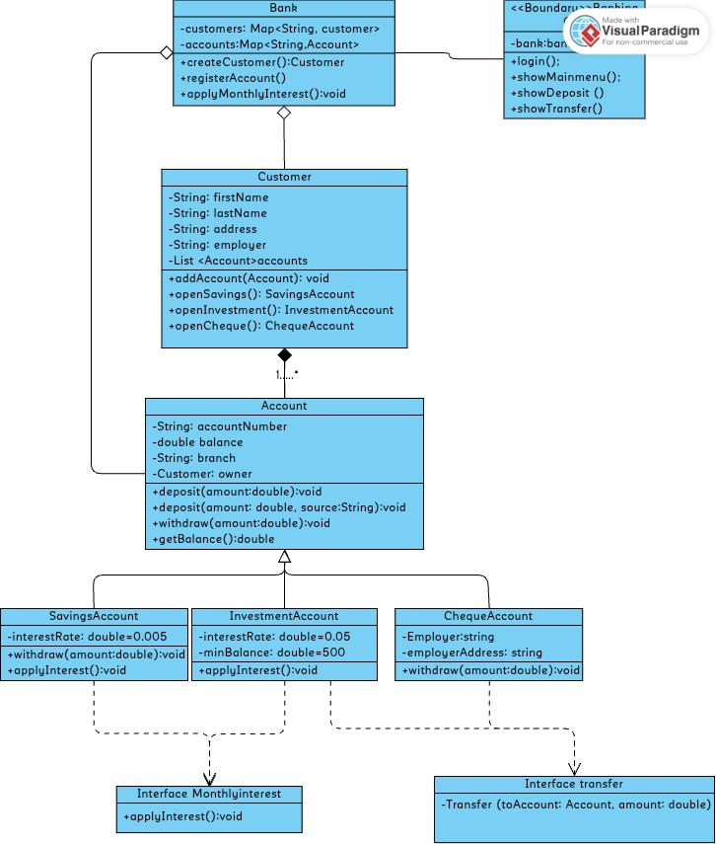
- Behavioural uml modelling
3.1 Sequence Diagrams

- Login

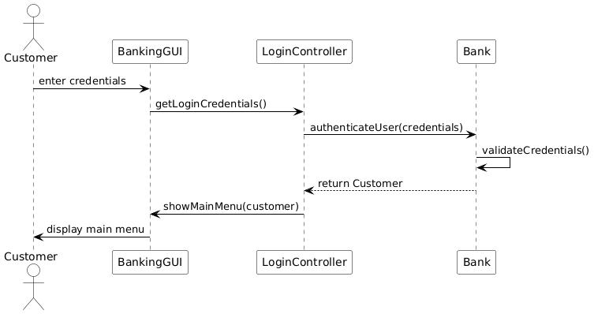

- Deposit

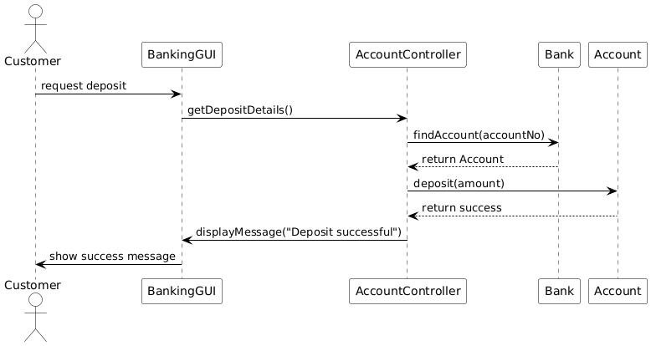

3.2 State Diagram
